Predicting Human Movement Using PageRank in an Urban Environment

Bin Jiang
Department of Land Surveying and Geo-informatics
The Hong Kong Polytechnic University, Hung Hom, Kowloon, Hong Kong
bin.jiang@polyu.edu.hk
Tel: 0852 2766 4335, Fax: 0852 2330 2992

Abstract
In this paper, we consider a city as an interconnected graph or topology in which nodes and links represent individual spaces and space intersections respectively. Based on the topology, we apply the weighted PageRank algorithm for ranking the individual spaces, and find surprisingly that the PageRank scores are significantly correlated to human movement both pedestrian and vehicle in four observed areas of central London. We also illustrate the fact that the topology demonstrates small world and scale free properties. The findings provide a novel justification as to why topological analysis can be used to predict human movement at a certain confidence level. We further conclude that this kind of analysis is no more than predicting a drunkard’s walking on a small world and scale free network.

Keywords: Topological analysis of networks, small world, power law, human movement, and PageRank

1. Introduction
A space, in the context of this paper, refers to a small scale space that is small enough to be perceived from a single vantage point. From this point of view, an urban environment that is too big to be viewed from a single vantage point is constituted by many (small scale) spaces. This way a city can be abstracted as an interconnected topology in which nodes and links represent individual street segments and their intersections respectively. Similarly, a building complex can be abstracted as a topology in which nodes represent individual rooms or corridors, and links represent the doors. The topology formed at either a city or a building level is an interconnected whole in which each node has a different topological status. For instance, some of them are well connected (with a high degree of connectivity), while others are less so. Assuming a frog randomly jumping from one node to its successors in the topology, the chance that the frog will visit individual nodes is decided by the connectivity of the nodes. This is simply based on the theory of Markov chains (e.g., Ching and Ng 2006). Although human movement is not as simple as the frog’s jumping, nodes’ connectivity does show some level of correlation to pedestrian and vehicle flows. However, the prediction effect is not very satisfactory. Researchers in the space syntax community (Hillier and Hanson 1984, Hillier 1996) have, over the past two decades, made enormous empirical studies and claimed that human movement both pedestrian and vehicle can be predicted by local integration, a node’s path length within two steps (see details in section 2.1). Local integration has now become a default indicator for human movement.

Despite the findings and progress in space syntax, seeking alternative metrics for ranking spaces has been a continuous effort. Recently Jiang (2006) has proposed the concepts of flow dimension and capacity for characterizing structural properties of individual streets, and applied these to real world networks including sexual, biological and urban street networks. More importantly, the phenomenal success of Google search engine has proved the effectiveness of the PageRank algorithm (Page and Brin 1998) in ranking pages of the World Wide Web. PageRank has also been used for ranking journal status (Bollen et al. 2006) and the importance of publications (Chen et al. 2006). For a more comprehensive overview of PageRank and its applications, the reader may refer to the research monograph by Langville and Meyer (2006). In this paper, we apply an extended PageRank algorithm, weighted PageRank (Xing and Ghorbani 2004), for ranking the individual spaces, and find that the PageRank scores are significantly correlated to human movement both pedestrian and vehicle in four observed areas of London. The correlation is even slightly better than that of local integration. This finding provides a novel justification as to why topological analysis can be used to predict human movement at a certain confidence level. Given the fact that the underlying topology exhibits small world and scale free properties, we conclude that this kind of analysis is no more than predicting a drunkard’s walking on a small world and scale free network (Note: in this paper, graph, topology and network are interchangeably used). This point will be elaborated in detail later in the paper.
The remainder of this paper is organized as follows. Section two introduces several metrics for ranking nodes of a graph, including space syntax metrics, small world and PageRank metrics. Section three presents our experiments with the aims of examining (1) small world and scale free properties of the London axial map and four areas around central London, (2) the correlation between the observed pedestrian and vehicle flows and the weighted PageRank scores, in comparison with the local integration. Based on the experiments, section four provides a justification of our findings, i.e., a never-get-stuck-or-tired random walker who has a preference while jumping to his successors. Finally section five concludes the paper and points to our future work.

2. PageRank Metrics for ranking spaces
PageRank is a key technology behind the Google search engine that decides the relevance and importance of web pages. Its computation is through a web graph in which nodes and links represent individual web pages and hotlinks. Obviously, the web graph is a directed graph, i.e., a hotlink from page A to B does not imply the other way around. The basic idea of PageRank is that a highly ranked node is one that highly ranked nodes point to (Page and Brin 1998). PageRank is used to rank individual web pages in a hyperlinked database. It is defined as follows:
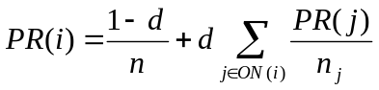 [6]
where n is the total number of nodes; ON(i) is the outlink neighbors (i.e., those nodes that point to node i); PR(i) and PR(j) are rank scores of node i and j, respectively; n_{j} denotes the number of outlink nodes of node j; d is a damping factor, which is usually set to 0.85 for ranking web pages.

The PageRank of a node relies on that of nodes that point to, i.e., a highly ranked node is one that highly ranked nodes point to. This is the beauty of the PageRank algorithm. The computation of PageRank is carried out iteratively starting with evenly distributed scores for individual nodes, and ending when a convergence is reached. The resulted PageRank scores are probabilities of individual nodes, and the sum of the scores for a web graph is equal to 1. The true meaning of the scores is their relative value, rather than an absolute value, for the ranking purpose. PageRank is nicely justified as a random surfer who continuously with probability d clicks hotlinks from one page to another. The random surfer jumps with probability (1-d) from one page to a randomly chosen page, or jumps with probability one to a randomly chosen page in case there is no hotlink for a page. PageRank is the stationary probability of a Markov chain (cf. Langville and Meyer 2006), and it is a variant of eigenvector centrality (Bonacich 1987) defined in social networks.

The above definition of PageRank has one problem, i.e. the PageRank of a node is evenly divided over the nodes to which it links (or outlink nodes). For example, the PageRank of node 1 is supposed to propagate into its four linked nodes 2, 3, 4 and 5. According to equation [6], each one of the four nodes gets the same amount of PageRank contributed by node 1. However, the propagation of the PageRank should follow an uneven rule, that the more popular nodes tend to get a higher proportion. In other words, it is proportional to the popularity of the linked nodes. This is exactly the basic motivation of weighted PageRank (Xing and Ghorbani 2004).

The weighted PageRank is defined as follows:

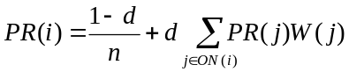 [7]

where weight W(j) is added to propagate a PageRank score from one particular node i to its outlink nodes. This is different from equation [6], where a PageRank score is evenly divided among its outlink nodes.

The weight W(j) represents relative popularity of node j among its counterparts, and it is defined as follows:

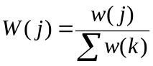 [8]
where k is counterpart nodes of j, w is the weight for individual links, indicating their popularity based on the percentage of inlinks and outlinks.

Initially PageRank is defined for web graphs that contain dangling nodes. However when it is applied to ranking spaces for an environment, the connected graph or topology is a connected and undirected graph, thus no dangling nodes. For any undirected graph, the computed PageRank scores are equivalent to the connectivity scores. In the following section, we will report our experiments to illustrate that (1) urban street networks demonstrate small world and scale free structures; (2) human movement is significantly correlated to the weighted PageRank, slightly better than to the local integration.

3. Experiments with three central London areas

3.1 The datasets
The datasets used in our experiments were studied in previous work on modeling human movement (Hillier et al. 1993, Penn et al. 1998). The London axial map forms an underlying topology, which was generated by taking each individual street or space as an axial line. The kind of axial map used is supposed to have a least number of longest axial lines. The London axial map consists of 17,321 lines, each of which represents approximately a space in reality (Figure 2a). The axial map provides a skeleton view of the world city, and it can be analyzed topologically. Three local areas in central London, namely Barnsbury, Clerkenwell, and South Kensington (Figure 2b), were selected for a more detailed investigation, in comparison to the entire London topology. Another dataset about human movement both pedestrian and vehicle in central London was obtained for verifying correlations between ranking metrics and human movement. These datasets are publicly available at http://eprints.ucl.ac.uk/archive/00001398/. A major reason why we adopt the datasets is that the datasets have been well studied previously (e.g. Hillier and Iida 2005, Carvalho and Penn 2004), becoming benchmark datasets in the space syntax community. Our aim is to investigate whether or not any alternative metric such as PageRank can be a good indicator for human movement in an urban environment.
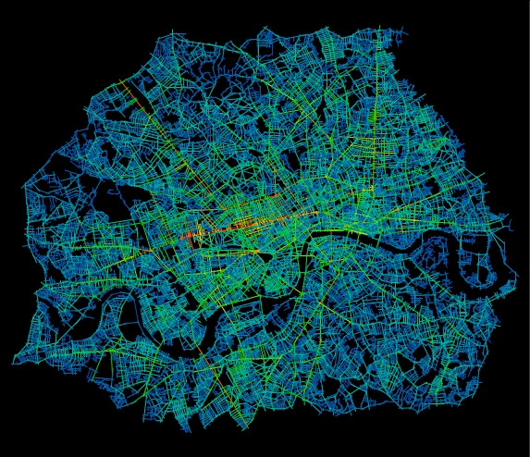 (a) | 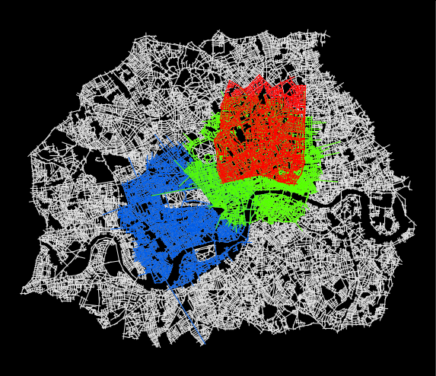  (b)

Figure 2: London axial map colored with local integration (a), and three test areas in central London (b): Barnsbury (red), Clerkenwell (green) and South Kensington (blue)

3.2 Small world and scale free structures
A first goal of the study is to assess the underlying topology of the London urban environment from a structural point of view. To this end, both path length and clustering coefficient were computed for the London topology, in comparison to its equivalent regular and random counterparts; path length to assess how one node separates from all other nodes within a topology, and clustering coefficient to indicate the level of clustering of the individual nodes of a topology. As we can see, the two metrics are initially defined as structural properties of individual nodes. However, they become a property of a topology by taking an average of the metrics for the individual nodes, which can be used to assess whether or not a real world network obeys the small world structure. Our computed result confirms the small world structure of the London axial map, i.e. on average the lines are shortly separated at a global level, and highly clustered at a local level. The illustrated small world property seems universal across the whole London region. Three test areas in central London exhibit the same kind of structure, although the average connectivity and path length differ from the entire topology to the three extracted ones (Table 1). The small world structure appears to suggest the kind of hidden geometry that Hillier et al. (1999) elaborated while arguing why space syntax works.

Table 1: Small world metrics for the London topology and its three subsets

Area | N |  | M | L | C |  | Lreg | Lrand |  | Crand
Barnsbury | 1,915 |  | 4.7 | 8.4 | 0.18 |  | 638.3 | 4.9 |  | 0.0025
Clerkenwell | 3,622 |  | 4.9 | 8.3 | 0.18 |  | 370.8 | 5.2 |  | 0.0014
Kensington | 2,742 |  | 4.7 | 8.1 | 0.16 |  | 914.0 | 5.1 |  | 0.0017
London | 17,321 |  | 4.2 | 15.9 | 0.17 |  | 5773.7 | 6.8 |  | 0.00024
N: the number of lines |  | M: the average connectivity |  |  |  | L: path length |  |  | C: clustering coefficient
Lreg: L for regular graph |  | Lrand: L for random graph |  |  |  | Crand: C for random graph

Another aspect of the so called hidden geometry, to my understanding, is that both connectivity and line length follow a power law distribution. A power law relationship between two variables x and y can be mathematically expressed as y = kx^{-α}. A very typical power law is called Zipf’s law, named after George Kingsley Zipf (1949) who initially discovered the law. Zipf observed that the frequency of English words occurred unevenly in a text. A typical power law curve starts at its maximum frequency and decreases sharply to a certain value and then continues to decrease very slowly all the way to infinity. Eventually an L-shaped curve emerges for the power law. To examine whether or not a data set follows a power law, we can simply plot the data set in a log-log plot. If we take a logarithm for the above power law function, i.e. Log(y) = -αlog(x) + log(k), clearly the L-shaped curve becomes a straight line on a log-log scale. Power law has been treated as a universal law, and has recently received a revival of research interests in statistical physics (Newman 2005). However, the ideal power law distribution is only applicable for a system with an infinite size in theory (Amaral et al. 2000). Our study illustrates that both connectivity and line length exhibit a sort of power law distribution. Figure 3 illustrates a series of log-log plots. Power law distribution is also called scale free property in the terms of Barabási and Albert (1999). This is not a surprising finding. The scale free property has also been illustrated in the previous study by Carvalho and Penn (2004), where line length demonstrates a scaling universality for over 30 urban environments.

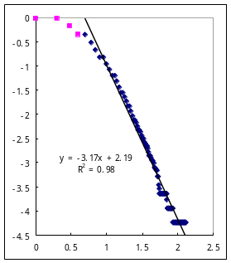  (a) London | 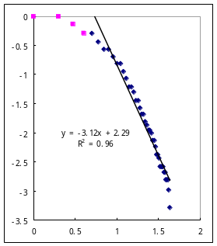  (b) Barnsbury | 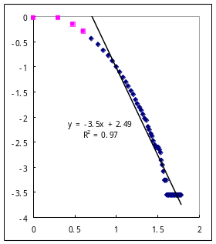  (c) Clerkenwell | 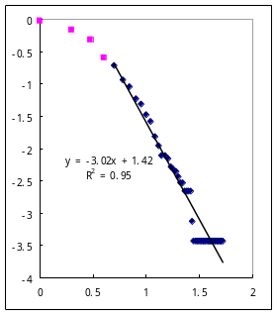(d) S. Kensington
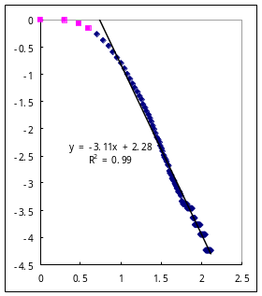  (e) London | 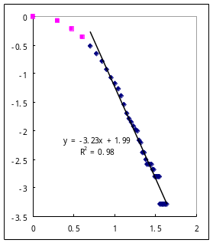  (f) Barnsbury | 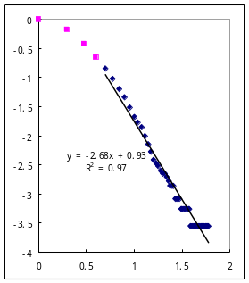  (g) Clerkenwell | 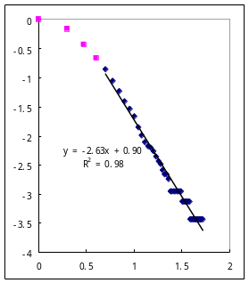(h) S. Kensington

Figure 3: Power law distributions of connectivity (a-d) and length (e-h) of the axial lines of the three test areas

To this point, we have illustrated that the London topology exhibits both small world and scale free properties. In other words, the urban environment shows neither randomness nor order, but a hidden order. This kind of structure resembles the semi-lattice that Alexander (1965) elaborated on, or what Hillier (1999) called hidden geometry.

3.3 Correlation between human movement and ranking metrics
Having illustrated the hidden structure, in this section we will examine which ranking metrics havethe best correlation to human movement. To this end, the dataset used for verification is observed pedestrian and vehicle flows for fifty minutes in almost all street segments around the four sites (Figure 4 and Figure 5). The number of gates set in the street segments varies from one site to another. The flows of individual gates are aggregated into their associated lines for correlation study. To our surprise, the weighted PageRank scores are significantly correlated to the pedestrian and vehicle flows, slightly better than local integration in the third decimal (Table 2). We have further noticed that the correlation between PageRank and movement gets better and better as the damping factor d increases. This observation is valid for both the standard PageRank and the weighted PageRank. Table 2 also indicates that the three space syntax metrics do correlate to human movement, and the difference of r-squares is very trivial. In contrast, the weighted PageRank with damping factor 1.0 is different from other PageRank scores with other values of the damping factor. Our study ignores other factors such as predominant land use, road width, and building height, as we seek purely a relationship between movement and ranking metrics. The distributions of pedestrian and vehicle flows are positively skewed. Therefore, before checking correlation, the flow rates are taken by the fourth root to give them more normal distribution. This adjusting process is applied to any metric if its distribution is skewed.

Table 2: R-squares for the correlation between ranking metrics and human movement
(NOTE: # = number of gates, connect.= connectivity, local = local integration with two steps, global = global integration, PR85 = PageRank with damping factor equal to 0.85, PR100 = PageRank with damping factor equal to 1.0, WPR99 = weighted PageRank with damping factor equal to 0.99, WPR100 = weighted PageRank with damping factor equal to 1.0)

Site name (mode, #) | Connect. | Local | Global | PR85 | PR100 | WPR99 | WPR100
Barnsbury (ped. 47) | 0.69 | 0.70 | 0.45 | 0.64 | 0.68 | 0.68 | 0.70
------------ (veh. 37) | 0.57 | 0.64 | 0.55 | 0.57 | 0.57 | 0.61 | 0.62
Clerkenwell (ped. 33) | 0.48 | 0.54 | 0.54 | 0.28 | 0.31 | 0.52 | 0.56
------------- (veh. 24) | 0.60 | 0.75 | 0.64 | 0.54 | 0.59 | 0.73 | 0.74
Kensington (ped. 46) | 0.59 | 0.62 | 0.41 | 0.42 | 0.59 | 0.62 | 0.62
------------- (veh. 31) | 0.79 | 0.77 | 0.65 | 0.79 | 0.79 | 0.78 | 0.79
Knightsbridge (ped. 67) | 0.32 | 0.38 | 0.49 | 0.29 | 0.32 | 0.36 | 0.38
--------------- (veh. 47) | 0.49 | 0.60 | 0.48 | 0.45 | 0.49 | 0.6 | 0.62
Mean | 0.566 | 0.625 | 0.526 | 0.498 | 0.543 | 0.613 | 0.629

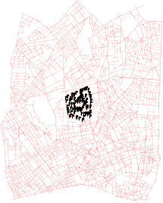  (a) | 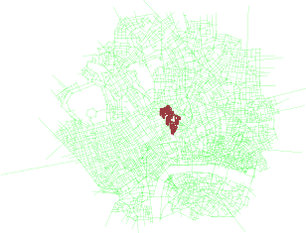  (b) | 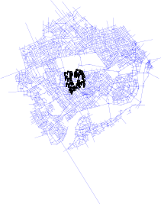  (c) | 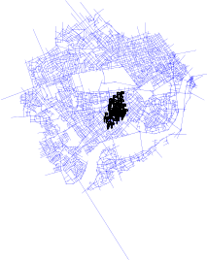  (d)

Figure 4: Four observed sites: Barnsbury (a), Clerkenwell (b), South Kensington (c) and Knightsbridge (d) embedded in the three central London areas

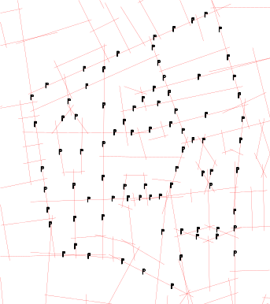  (a) | 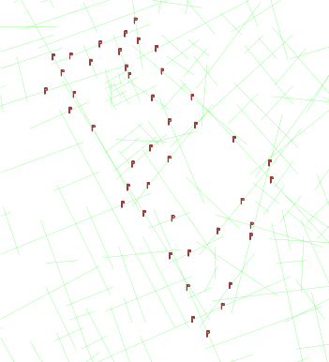  (b)
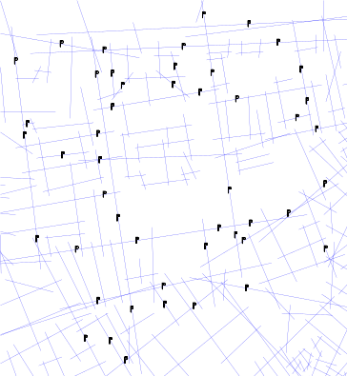  (c) | 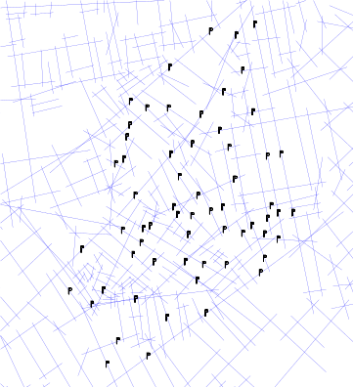  (d)

Figure 5: Enlarged view of the four observed sites: Barnsbury (a), Clerkenwell (b), South Kensington (c) and Knightsbridge (d)

4. Justification of our findings
The above experiments end up with two major findings: (1) the underlying topology of an urban environment is far from random, but exhibits small world and scale free structures; (2) the weighted PageRank is significantly correlated to human movement. In this section, we will justify the findings from the point of view of the random walk (Woess 2000). In order to do so, it is important to note that the urban topology differs from a web graph in two respects. Firstly, the topology is an undirected graph, while a web graph is directed. Secondly, because the topology is undirected, the topology contains no dangling nodes. The standard PageRank for a web graph is justified as a random surfer that has the following behavior:

IF (a node has no successors) THEN
with probability 1 it jumps to a randomly chosen node
ELSE
with probability d it moves to one of its successors with a uniform probability, AND
with probability (1-d) it jumps to a randomly chosen node
END

In words, the above behavior can be expressed in alternative ways. If the random surfer gets stuck, he will jump out to a randomly chosen node; otherwise, with probability d he moves to one of its successors with a uniform probability and with probability (1-d) he jumps to a randomly chosen node. Or simply stated, the behavior says that the random surfer jumps to a randomly chosen node when he gets stuck and tired; otherwise he moves to one of its successors with a uniform probability.

Because of the aforementioned differences between the urban topology and a web graph, we justify our findings by a random walker. The random walker never gets stuck (as there are no dangling nodes in the urban topology) or tired (as d is set to 1.0), and always (i.e., with probability 1) moves to one of its successors with non-uniform probability, i.e., well connected streets are more favorable. Thus the above weighted PageRank for predicting human movement in an urban environment can be simplified as follows:

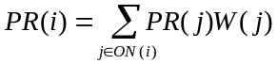 [9]

where W(j) keeps the same definition as in Equation [8].

Equation [9] provides a justification for our findings. It can be used to predict human movement within an urban environment at a certain confidence level. However, precaution should be taken seriously when we put the theory into practice. As we can see, over 60% of human movement can be predicted or explained purely from a topological point of view. In terms of statistics, the other 40% is not predictable, and it may relate to land use, building height and road width, etc. It is also important to point out that the 60% prediction is based on a corrected axial map which consists of the least number of longest visibility lines.

5. Conclusion and further work
This paper has added new insights into ranking spaces or topological analysis of urban environments for predicting human movement. We examine the topological structure of London, and find that it exhibits small world and scale free structures. We further discover that human movement is significantly correlated to the weighted PageRank scores, even slightly better than the local integration. Based on the PageRank random surfer model, we have justified our findings using a never-get-stuck-and-tired random walker who moves to its successors with non-uniform probability. This novel justification helps to answer the question why topological analysis can be used to predict human movement in an interconnected urban environment at a certain confidence level. This justification is different from the conventional one suggested by Hillier (1999), i.e., people tend to take paths that minimize trip length or maximize trip efficiency. However, it is not justified with the conventional one that why sometimes local integration has better correlation than global integration if to maximize trip efficiency. Our justification seems well supported both theoretically and empirically.

This study is based on the London datasets, which were collected using a very traditional data collection method, i.e., manually counting the number of vehicles or pedestrians through a gate. However, modern sensor technology provides far more advanced and accurate methods for data acquisition about human movement. We foresee that the deployment of the new technology or the so called location-based services (Jiang and Yao 2006) will make new traffic datasets available for further verification. It is important to point out that we adopted only axial line representation for an urban environment. What if we adopt alternative topological representations based on named streets (Jiang and Claramunt 2004)? or strokes (Thomson 2003), the line segments with a good continuity perceptually? Another observation derived from the study is that both local integration and weighted PageRank correlated significantly to human movement, but the two metrics did not correlate to each other. All these questions and observations deserve further research in the future.

Acknowledgement
The study reported in the paper was financially supported by a Hong Kong Polytechnical University research grant. The author is grateful to Chengke Liu for his research assistance, and Amy Langville and David Gleich for their timely advice on the efficient computation of PageRank. However, I alone am responsible for any shortcomings.

References:
Alexander C. (1965), A city is not a tree, Architectural Forum, 122(1+2), 58-62.
Amaral L. A. N., Scala A., Barthelemy M. and Stanley H. E. (2000), Classes of behaviour of small-world networks, Proceedings of the National Academy of Sciences, 97, 11149-11152.
Barabási, A.-L. and Albert R. (1999), Emergence of scaling in random networks, Science, 286, 509-512.
Batty M. (2004), A new theory of space syntax, CASA working paper #75, available at http://www.casa.ucl.ac.uk/publications/full_list.htm
Bollen J., Rodriguez M. A. and Sompel H. V. (2006), Journal Status, Preprints, arXiv:cs.DL/0601030 v1.
Bonacich, P. (1987), Power and centrality: a family of measures, American Journal of Sociology, 92, 1170-1182.
Carvalho R. and Penn A. (2004), Scaling and universality in the micro-structure of urban space, Physica A, 332, 539 – 547.
Chen P., Xie H., Maslov S., and Redner S. (2006), Finding scientific gems with Google, Preprints, arXiv:physics/0604130 v1.
Ching W. K. and Ng M. K. (2006), Markov Chains: models, algorithms and applications, Springer: Berlin.
Hillier B. (1999), The hidden geometry of deformed grids: or, why space syntax works, when it looks as though it shouldn't, Environment and Planning B: Planning and Design, 26, 169-191.
Hillier B. and Hanson J. (1984), The Social Logic of Space, Cambridge University Press: Cambridge.
Hillier, B. (1996), Space Is the Machine: a configurational theory of architecture, Cambridge University Press: Cambridge.

Hillier, B. and Iida, S. (2005), Network and psychological effects in urban movement. In: Cohn, A.G. and Mark, D.M. (eds.), Proceedings of the International Conference on Spatial Information Theory, COSIT 2005, Ellicottsville, N.Y., U.S.A., September 14-18, 2005, Springer-Verlag: Berlin, 475-490.
Hillier, B., Penn A., Hanson J., Grajewski T. and Xu J. (1993), Natural movement: configuration and attraction in urban pedestrian movement, Environment and Planning B, 20, pp. 29-66.

Jiang B. (2006), The flow dimension and capacity for structuring urban street networks, Preprints, arXiv.org/physics/0609095/
Jiang B. and Claramunt C. (2002), Integration of space syntax into GIS: new perspectives for urban morphology, Transactions in GIS, 6(3), 295-309.
Jiang B. and Claramunt C. (2004), Topological analysis of urban street networks, Environment and Planning B: Planning and Design, 31(6), 151- 162.
Jiang B. and Yao X. (2006), Location-based services and GIS in perspective, Computers, Environment and Urban Systems, 30(6), 712 - 725.
Langville A. N. and Meyer C. D. (2006), Google's PageRank and Beyond: the science of search engine rankings, Princeton University Press: Princeton, N.J.
Newman, M. E. J. (2005), Power laws, Pareto distributions and Zipf's law, Contemporary Physics，46: 323–351.
Page L., Brin S. (1998), The anatomy of a large-scale hypertextual Web search engine, Proceedings of the seventh international conference on World Wide Web 7, 107-117.
Penn A., Hillier B., Banister D., and Xu J. (1998), Configurational modeling of urban movement networks, Environment and Planning B: planning and design, 25, 59 - 84.
Ratti C. (2004), Space syntax: some inconsistencies, Environment and Planning B: Planning and Design, 31, 487 – 499.
Thomson R. C. (2003), Bending the axial line: smoothly continuous road centre-line segments as a basis for road network analysis, 4th International Space Syntax Symposium, London.
Watts D. J. and Strogatz S. H. (1998), Collective dynamics of ‘small-world’ networks. Nature, 393, 440–2
Woess W. (2000), Random Walks on Infinite Graphs and Groups, Cambridge tracts in mathematics 138, Cambridge University Press: Cambridge.
Xing W. and Ghorbani A. (2004), Weighted PageRank algorithm, Second Annual Conference on Communication Networks and Services Research CNSR’04, Fredericton, N.B. Canada, 305 – 314.
Zipf G. K. (1949), Human Behaviour and the Principles of Least Effort. Addison Wesley: Cambridge, MA

